Prognostic Factors of Endoscopic Third Ventriculostomy Outcome in Infants

Mohamed M Elmaghrabi, Moataz A Elawady, Mohammed Mourad

Neurosurgery Department, Faculty of Medicine, Benha University, Benha, Egypt
Abstract
Background: Endoscopic third ventriculostomy (ETV) is considered a successful tool for the management of obstructive hydrocephalus. A higher failure rate in infants is reported in many works of literature.
Methods: Thirty-two patients under the age of one year were operated on for obstructive hydrocephalus using the Endoscopic Third Ventriculostomy (ETV) at both the Neurosurgery Department of Benha University and Benha Children Hospitals between July 2018 and July 2020 were included in this study.
Results: Ages ranged between 10 and 320 days with a median age of 131 days (IQR=60-200). There is a significant difference in age between infants with success and failure outcomes. Idiopathic aqueduct stenosis was found in 100% of the succeeded patients and in 41.7% of the failed patients which is statistically insignificant. A Higher success rate of a moderate course of macrocephaly than a rapid course with a higher failure rate is statistically significant.
Conclusion: The success rate in infant patients especially those with an age is less than 1 year is not as favorable as in older children. In our study, possible prognostic factors for the success of ETV are older infants, idiopathic etiology of obstructed hydrocephalus, and moderate course of macrocephaly.
Keywords: Prognostic factors, endoscopic, ventriculostomy, infants

Introduction:
Endoscopic third ventriculostomy (ETV) is considered a safe successful procedure for treating obstructive hydrocephalus.⁹

In the 1970s and shortly before this procedure became familiar for a wide spectrum of applications using assisting techniques such as stereotactic or ventriculoscopic guidance and in the late 1980s, it gained more and more popularity as a result of the development of better and smaller endoscopes facilitating this technique with an acceptable rate of complications.1 However, in some patients who eventually needed a shunt, ETV failed to achieve good results as it is cleared later on that the rate of success depends on many factors like the cause of hydrocephalus or patients’ age of presentation. In infants, however, a higher failure rate is documented.²

Objective
In our study, we investigate outcome prognostic factors of ETV surgery for obstructive hydrocephalus’ patients during their first year of life.

Methods
Type of the study: this is a clinical cohort prospective study.

Patients: All patients under the age of one year that were operated on for obstructive hydrocephalus by an endoscopic third ventriculostomy (ETV) at the Neurosurgery Department of Benha University and Benha Children Hospitals between July 2018 and July 2020 as the first line of surgery were included in this study. ETV failure was defined as a subsequent need for shunt implantation.

Surgical details:
Planned procedures on a no emergency basis were done for all patients who were placed supine and underwent general anesthesia. A tape was used to fix the infant’s head. A frontal approach had used, right sided in 29 cases or left in 3 cases, which guided by size of the lateral ventricles. A surgical skin incision located at the lateral margin of the anterior fontanel (modified Kocher burr hole different according to head size) was used to apply a rigid endoscope (Lotta ventriculoscope6°, working channel 2.9 mm with operating sheath and obturator 6.8mm; Karl Storz, Tuttlingen, Germany) into the frontal horn of the lateral ventricle. Then, through the foramen of Monro, the choroid plexus was tracked. Identification of the thinned floor of the third ventricle was done. The floor was perforated as in figure (1) at the typical site, thinned out tuber cinereum, between the infundibular recess of the pituitary stalk and the two mamillary bodies. A Fogarty balloon catheter (3 or 4 French) is used to perform the fenestration. In selected cases of a tough floor, an endoscopic scissor was used to open it. Then the endoscope was introduced through the ventriculostoma. Any other detected membranes (as lilliequist membrane) were also fenestrated until flow was adequate into the prepontine cistern. Stepwise withdrawal of the endoscope is securing all slight bleeding sites via irrigation and waiting. Finally, the hole was closed with an absorbable gelatin sponge after the watertight closure of the dura then the wound was closed with closely approximated sutures for the prevention of postoperative CSF leakage. Postoperatively, the patients were shifted to a regular pediatric ward except for one case who needed postoperative intensive care due to other health problems unrelated to neither hydrocephalus nor the procedure.¹¹

Follow-up: All patients were assessed postoperatively with clinical examination and repeated imaging with a follow-up period ranging from 12-18 months. Patients were classified into two groups: Group I: successfully treated patients (Figure 2) and group II: failed procedure (Figure 3). The success of the ETV procedure should fulfill the following criteria: no further surgical procedure is needed; decreasing or stopping of increase of the head circumference; no more bulge of the fontanel nor other signs of elevated intracranial pressure with none to three ventricular taps (for fontanel bulge, subcutaneous wound collection, or wound CSF leak) through anterior fontanel under complete aseptic conditions to drain CSF until the flow was normalized.

Ethical approval: This research was approved by the Research Ethics Committee (REC) of the faculty of medicine, Benha University.
All procedures were performed in this study involving that human participants were under the ethical standards of the institutional and/or national research committee and concordance with the 1964 Helsinki declaration and its later amendments or comparable ethical standards. From parents of the patients, a written informed consent was signed after complete information of all study steps.

Data management: The program used for statistical analysis was SPSS version 20. Quantitative data were analyzed using mean, standard deviation (SD), median, and inter-quartile range (IQR), while frequency and percentage were used with qualitative data. Student t-test was used to compare means of different groups, while Fischer exact test to compare frequencies. Box plot was performed. The corresponding distribution tables were consulted to get the “P” (probability value). Statistical significance was accepted at a P-value ≤0.05while a P-value > 0.05 was considered insignificant.

Results
Thirty-two patients with age under one year with obstructive hydrocephalus underwent ETV, with no sex difference in the number of patients between girls and boys. Ages ranged from 10 to 320 days with a median age of 131 days (IQR=60-200).

The diagnosis was aqueduct stenosis (AS) in all infants, proven by MRI. The etiology of the aqueduct stenosis was idiopathic in eighteen patients (56.25%), post-meningitic in six patients (18.75%), and post-hemorrhagic in eight patients (25.0%). The patient’s criteria are summarized in table 1.

After ETV, twenty-four patients redeveloped manifestations of high intracranial pressure and all of them underwent another surgery for V-P shunt device insertion without inspection of the stoma with a median an interval between ETV and shunt operation was 32.5 days.

There is a significant difference (p<0.05) regarding age/days (median, IQR) between infants with success (280.0, 223.0-300.0) and failure (73.5, 39.0-131.0) outcomes as in figure 4.

Table 2 shows that idiopathic aqueduct stenosis was found in eight out of eight (100%) of the succeeded patients and in ten out of twenty-four (41.7%) of the failed patients which is statistically insignificant to the success rate in patients with idiopathic aqueduct stenosis was eight out of eighteen (44.44%). The course of macrocephaly (increase head circumference above 2 SD according to age and sex) from its onset shows that the rapid accumulation of CSF with severe head enlargement was inversely related to success as the higher success of the moderate course in seven from eight patients (87.5%) than a rapid course with higher failure rate in eighteen out of twenty-four patients (66.7%) which is statistically significant.

The complications (six patients, 18.75%) included CSF leak in three patients, intraventricular hemorrhage in two patients, and meningitis only in one patient. In the two patients with intraventricular hemorrhage during surgery, temporary extraventricular drainage was placed in one patient postoperatively. In all three patients with a wound CSF leak, we performed three successive ventricular taps through the anterior fontanel with still leaking. However, all these complicated patients required a V-P shunt.

Discussion

Karimy et al. in a previous study documented the impact of the age of the patient on the outcome of ETV in infants. Setting a limit of the age of, for example, 1 year or 6 months, or 2 years is one of the most commonly used approaches to compare either the success or the failure rates in patients around this age limit. The cut-off difference in age may be one of the factors contributing to variable results in several different published studies.⁷

El-Ghandour in another study analyzed the patient group who suffered from idiopathic aqueductal stenosis and found that the median age among successfully done cases was 10 months and among non-improved cases was 3.0 months. These findings match our study concluding a clear strong impact of age, even if etiologic factors are being excluded.⁵

In our study we found similar results documenting a clear difference in age between successfully and unsuccessfully done cases (9.1 vs. 2.8 months). These wide distributions of age within the two mentioned age groups confirm higher failure rates of ETV in the very early months of life.

The overall success rate in our patients (25%) was obviously lower than the average success rate in other publications; a single larger international series documented that the success rates for ETV at 3, 6, and 12 months were as follows 68, 66, 66 %.⁸

The age dependency in both literature and our cases may be a result of the low capacity of CSF resorption in younger children which can alter CSF dynamics in patients with under-developed arachnoid villi may play an important role in the failure of ETV.⁴

A higher tendency for the formation of new arachnoid membranes is another theory to explain the etiology of obstructive hydrocephalus.¹⁵ It can also explain our ventriculoscopic observations of a closed stoma or new arachnoid membranes during the second procedure of either ETV or shunt insertion in five patients.

Matching with our finding Surash et al, documented detection of closure of the stoma in seven patients and was narrowed in one patient, they also found the second membrane was found under the original patent stoma in another two patients.¹⁴

In our patients, idiopathic aqueduct stenosis was found in 100% of successfully done cases and 41.7% of unsuccessfully done cases; the rate of success in patients with idiopathic aqueduct stenosis was eight out of eighteen (44.44%), which can explain clearly that the success of ETV is not only related to the age of the patient but also depends on the etiology. The success rate can increase to 80% especially if both factors were favorable.¹²

Confirming the results of Ajay et al. we advocate ETV as a safe procedure with a success rate for children with aqueduct stenosis.³ The impact of etiology concerning ETV success in the literature was different. The percentage of patients with “pure” aqueduct stenosis without the presence of other associated pathologies like meningitis, hemorrhage, malformations, etc. was 44% in successful cases and 46% in cases of failure.^{10, 12}

In our study, we found that the success rate significantly increased with moderate course from onset (87.5% of success patients) but with rapid course slightly more with failure rate (66.7% of failed patients). No available study is concerned with this prognostic factor yet.

The second procedure of ETV is reported as an option worth trying in older children who can be performed with a reasonable chance to restore patency of the closed stoma and avoid placement of VP shunt. It is important to detect subarachnoid adhesions in the cistern in preoperative imaging study to select potential candidates.¹³ But in our study all cases with no improvement after ETV received a shunt device without inspection of the stoma.

There are documented many cases of successfully done second ETVs in babies on the other hand the role of second ETV in young infants may be still questionable.⁶ There are specific factors that indicate favorable prognostic for second ETV such as the presence of a closed or very small stoma.¹⁶

We, therefore, recommend trialing a second ETV trial in unsuccessfully responded cases after the initial procedure, especially of closed ventriculostoma or new membranes blocking CSF circulation to evaluate its success.

Conclusion
ETV is an easy procedure that can be carried out in infants; however, the success rate in infants is still not as good as in older children. In our study, possible prognostic factors which favor the success of ETV are older infants, idiopathic etiology of obstructive hydrocephalus, and moderate course of head enlargement. We and Zohdi et al; conclude that serious complications of shunt lead us to evaluate if ETV is more successful17 and how to increase the success rate in further studies.

Acknowledgment:
The authors thank the parents of all included children.

Funding: This study had no funding from any resource.

Competing interests:
The authors declare that they have no conflict of interest.

References
- Baldauf J, Oertel J, Gaab MR, Schroeder WS: Endoscopic third ventriculostomy in children younger than 2 years of age. Child's Nervous System; 2007, 23:623–626.
- Balthasar AJR, Kort H, Cornips EMJ, Beuls EAM, Weber JW, Vles JSH: Analysis of the success and failure of endoscopic third ventriculostomy in infants less than 1 year of age. Child's Nervous System; 2007, 23:151–155.
- Bisht A, Suri A, Bansal S, Chandra PS, Kumar R, Singh M, Sharma BS: Factors affecting surgical outcome of endoscopic third ventriculostomy in congenital hydrocephalus. J ClinNeurosci; 2014, 21:1483-9.
- El Damaty A, Marx S, Cohrs G, Vollmer M, Eltanahy A, El Refaee E, Baldauf J, Fleck S, Baechli H, Zohdi A, Synowitz M, Unterberg A, Schroeder HWS: ETV in infancy and childhood below 2 years of age for treatment of hydrocephalus. Child's Nervous System; 2020, 36:2725-2731.
- El-Ghandour NMF: Endoscopic third ventriculostomy versus ventriculoperitoneal shunt in the treatment of obstructive hydrocephalusdue to posterior fossa tumors in children. Child's Nervous System; 2011, 27:117–126.
- Javadpour M, Mallucci C, Brodbelt A, Golash A, May P: The impact of endoscopic third ventriculostomy on the management of newly diagnosed hydrocephalus in infants. Pediatr. Neurosurg; 2001, 35:188-194.
- Karimy JK, Duran D, Hu JK, Gavankar C, Gaillard JR, Bayri Y, Rice H, DiLuna ML, Gerzanich V, Simard MJ, Kahle KT: Cerebrospinal fluid hypersecretion in pediatric hydrocephalus. Neurosurgical Focus; 2016, 41(5):E10.
- Kulkarni AV, Sgouros S, Constantini Sh: International Infant Hydrocephalus Study: initial results of a prospective, multicenter comparison of endoscopic third ventriculostomy (ETV) and shunt for infant hydrocephalus. Child's Nervous System; 2016, 32:1039-48.
- Limbrick DD Jr., Baird LC, Klimo P Jr., Riva-Cambrin J, Flannery AM: Pediatric hydrocephalus: systematic literature review and evidence-based guidelines. Part 4: Cerebrospinal fluid shunt or endoscopic third ventriculostomy for the treatment of hydrocephalus in children. J Neurosurg Pediatrics (Suppl); 2014, 14:30–34.
- Mazzola CA, Choudhri AF, Auguste KI, Limbrick DD Jr., Rogido M, Mitchell L, Flannery AM: Pediatric hydrocephalus: systematic literature review and evidence-based guidelines. Part 2: Management of posthemorrhagic hydrocephalus in premature infants. J Neurosurg. Pediatr; 2014, 14 Suppl 1:8-23.
- O’Brien DF, Seghedoni A, Collins DR, Hayhurst C, Mallucci CL: Is there an indication for ETV in young infants in aetiologies other than isolated aqueduct stenosis? Child's Nervous System; 2006, 22:1565–1572.
- Ogiwara H, Dipatri AJ, Alden TD, Bowman RM, Tomita T: Endoscopic third ventriculostomy for obstructive hydrocephalus in children younger than 6 months of age. Child's Nervous System; 2010, 26:343-347.
- Peretta P, Cinalli G, Spennato P, Ragazzi P, Ruggiero C, Ferdinando Aliberti, Carlino Ch, Cianciulli E: Long-term results of a second endoscopic third ventriculostomy in children: retrospective analysis of 40 cases. Clinical Trial; 2009, 65: 539-47.
- Surash S, Chumas P, Bhargava D, Crimmins D: A retrospective analysis of revision endoscopic third ventriculostomy. Child's Nervous System. 2010, 26:1693-1698.
- Teo C: Third ventriculostomy in the treatment of hydrocephalus: experience with more than 120 cases. In:Hellwig D, Bauer BL (eds) Minimally Invasive Techniques for Neurosurgery. Springer, Berlin Heidelberg New York, 1998, 73–76.
- Torres JL, López BR, Moroño SI, Sanjuán AR, Rodríguez AS, Larrazábal LC, Ruiz JC, Sánchez MAA: Re-do endoscopic third ventriculostomy. Retrospective analysis of 13 patients. Neurocirugia (Astur: Engl Ed); 2021, 8;1130-1473.
- Zohdi A, El Damaty A, Aly K, El Refaee E: Success rate of endoscopic third ventriculostomy in infants below six months of age with congenital obstructive hydrocephalus (a preliminary study of eight cases). Asian J Neurosurg; 2013, 8(3):147-52.

Tables:

Table 1: Characteristics of the studied group
ETV cases | No (32)
Sex n (%)  Male  Female | 16(50.0)  16(50.0)
Etiology of AS n (%)  Idiopathic AS  Post-meningitic AS  Post-hemorrhagic AS | 18(56.25)  6(18.75)  8(25.0)
Macrocephaly progression (>2SD for age & sex) n(%)  Rapid  Moderate | 19(59.4)  13(40.6)
Outcome n (%)  Failure  Success | 24(75.0)  8(25.0)
*Interval ETV-Shunt (days) (24 cases)  Mean ±SD  Median (IQR) | 32.92 ±12.70  32.5 (30-40)
*Only for failed cases.

Table 2: Comparison between patients with success and failure outcome regarding to etiology and course
Outcome | Success (8) | Failure (24) | Fischer exact test | P value
Etiology of AS n (%)  Idiopathic AS  Post-meningitic AS  Post-hemorrhagic AS | 8(100)  0(0.0)  0(0.0) | 10(41.7)  6(25.0)  8(33.3) | 5.06 | 0.08
Macrocephaly course (>2SD for age & sex) n (%)  Rapid  Moderate | 1(12.5)  7(87.5) | 18(66.7)  6(33.3) | 7.3 | 0.007*
*significant

Figures:

ab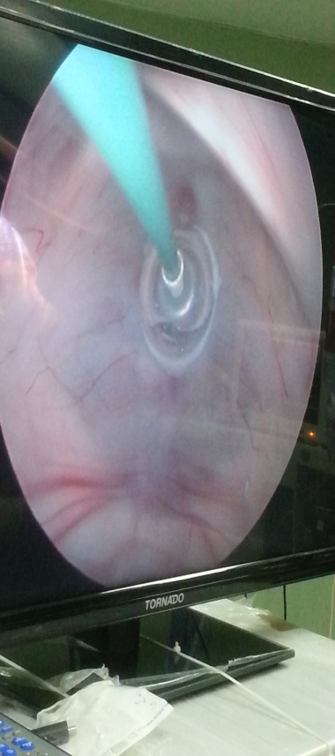
c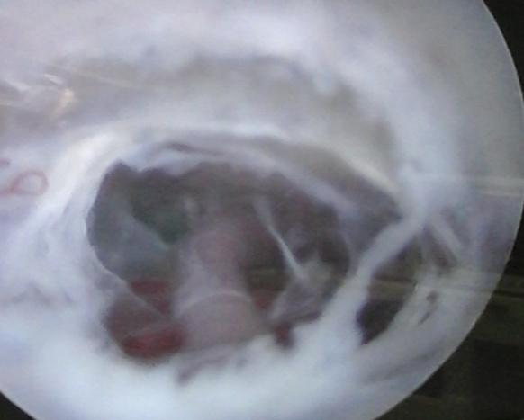d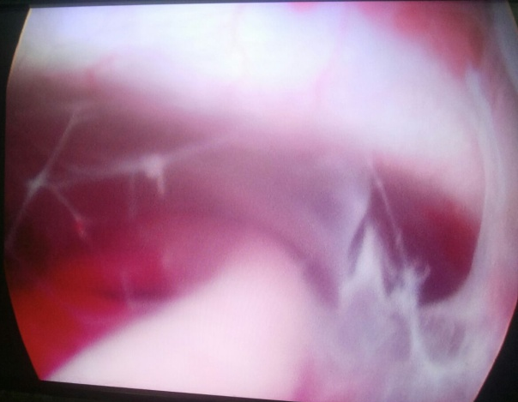
Figure (1) a-d: Surgical steps of ETV; a) initial opening in tuber cinereum by fogarety catheter. b) dilatation of opening by inflation of fogarety ballon. c) multilayer lilliequist membrane. d) visual confirmation of an adequate opening to prepontine cistern.

a
b
Figure (2) a,b: CT brain images in successful ETV case; a) Pre op, b) Post op 3 months showing lax sulci and disappeared transependymal permeation.

a
b
Figure (3) a,b: CT brain images in failed ETV case; a) Pre op, b) Post op 2 months with progressive decrease thickness of brain mantle.

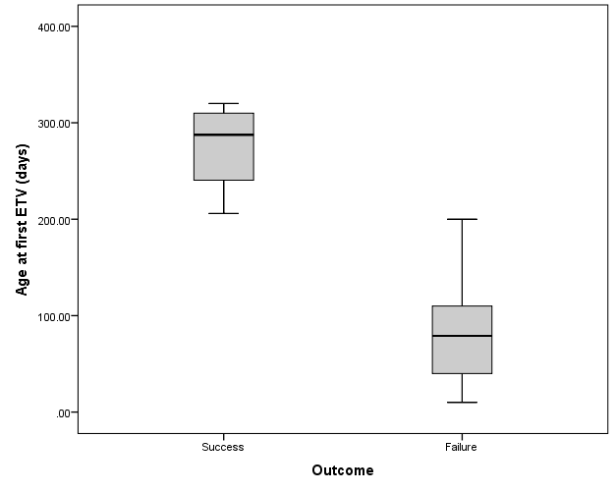
Figure (4): Box plot of differences between successful and failed cases according to age at day of ETV.

